Sebastian Weaver

Processing Recap Muscoskeletal modelling and gait analysis

Auckland Biengineering Institute 19/11/18

Contents

1.0 Introduction 3

2.0 Nexus 3

2.1 Skeleton Modelling 3

Markers 3

Segments 4

Linkages 6

2.2 Applying a VST 8

Subjects 8

Trajectories 8

Auto Initialising Labels 9

Manual Labelling 12

Timeframe considerations 13

2.3 Gap Filling 13

Quality 13

Path Switching 14

Path Filling 15

2.4 Exporting Data 18

ASCII RAW DATA 18

MOT DATA Opensim 18

TRC DATA Opensim 18

3.0 Data Filtering 18

3.1 EMG Data 18

EMG data in Nexus 18

EMG Data in Matlab 18

3.2 IMU Data 18

4.0 Opensim 19

4.1 Original Model 19

4.2 Static scaling 19

4.3 Inverse Kinematics 19

4.4 Inverse dynamics 20

5.0 References 20

Table Of Figures

Figure 1 Creating a VST 3

Figure 2 Creating a VST Reconstruct 4

Figure 3 Creating a VST 4

Figure 4 Creating a Torso Segment 5

Figure 5 Creating a torso segment (subject tab left) (perspective screen right) 6

Figure 6 Applying a VST 8

Figure 7 Marker trajectories for pelvis section 9

Figure 8 Pipeline 10

Figure 9 Checking for mislabels 11

Figure 10 Label/edit tab 12

Figure 11 Timeframe Considerations 13

Figure 12 Starting Quality Tab 14

Figure 13 Finished Quality Tab 14

Figure 14 Path Switching 15

Figure 15 Path switching direction 15

Figure 16 Gap filling tab 16

# Introduction

This report covers the processes undergone in my Summer Research role with Julie Choisne and Ted Yeoung over the 2018/2019 break. The project covers the reconstruction of markers in nexus and bodybuilder, analyses of EMG and IMU data, and inverse kinematics and dynamics in Opensim.

The research is aimed as a proof of concept, justifying the use of IMU markers in the place of full body markers. Data was collected throughout various adult and child participants in nexus live at AUT millennium.

# 2.0 Nexus

Nexus was chosen as the primary marker reconstruction program due to previous experience in the program and its interface with other reconstruction programs and IMU.

Marker reconstruction is required as during data collection, markers are often obstructed by clothing, other body parts and can go out of range of the camera. Reconstruction is used to create a skeletal base from the exterior markers and elimin0ate these gaps using various functions available to predict a best fit.

## 2.1 Skeleton Modelling

Skeletal modelling is based on the given marker set placement. Assuming groups of markers (segments) as rigid bodies of the bone underneath. The skeleton is determined before data collection for correct placement of markers. The following instructions outline the process for creating a new skeleton model (VST)

### Markers

Markers show up on nexus as white spheres and are initially unlabelled. To begin any analyses in nexus there must first be a subject. A subject contains a marker set, segments and linkages, making a complete skeleton. To create a blank skeleton click the white + symbol in the symbols tab, and enter the desired subject name.

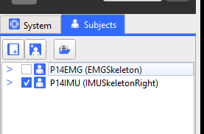

Figure 1 Creating a VST

Following this we will see a red subject appear with an asterix next to it. **The** **asterix tells us that the subject is not saved. The red writing tells us that the subject has unlinked segments.** We must also untick other activated subjects, as the pipelines can only run one subject at a time.

If the screen does not show any dots, you must use the reconstruct tool at the top of the page, shown as a black bubbles icon.

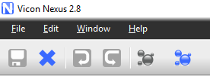

Figure 2 Creating a VST Reconstruct

If we are ever looking to see the breakdown of our subject, we can use the drop down menu to show markers, segments and joints. At this stage they are all empty.

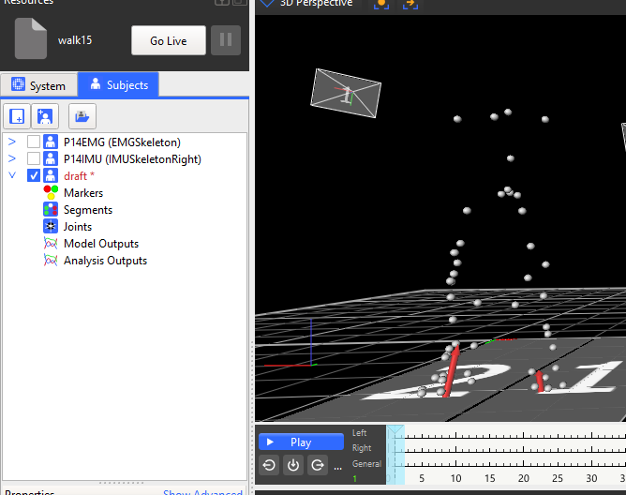

Figure 3 Creating a VST

### Segments

To begin creating segments we must access the subject’s plane on the right hand side of the screen. Select the appropriate subject from the drop down menu at the top. And type in the first segment name. We then press create, in this case we are creating a new segment called “torso”.

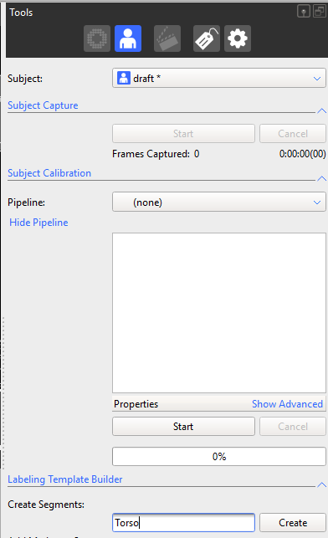

Figure 4 Creating a Torso Segment

We are then told to choose an origin marker. This is the most **proximal marker**, i.e. the marker first influenced by the objects movement. For the torso, this will be the marker closest to the pelvis. We then proceed to select our remaining markers, the most proximal markers first. We can now reselect create to confirm this choice.

We will now see the segment has changed colour and linked together. And our subject tab on the left hand side has been updated, creating markers and a torso segment.

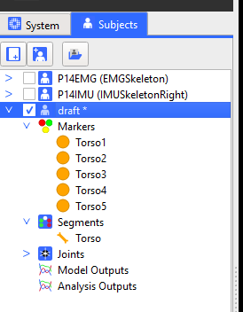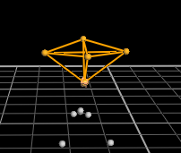

Figure 5 Creating a torso segment (subject tab left) (perspective screen right)

We may now choose to rename and recolour our markers and segment to match our marker labels. This can be done by selecting the appropriate marker by selecting it on the perspective screen or on the subject tab then changing this below on the properties section below the subject tab.

Again we will see our subject has been updated. And we can hover over markers to check they are labelled correctly.

We will now proceed to create the rest of our segments using the same process.

### Linkages

When this is correctly done we will see our segments all highlighted and coloured**. We will also see the segment names in bold** on the left hand side**, if they are grey not black, you will not be able to link the segments.**

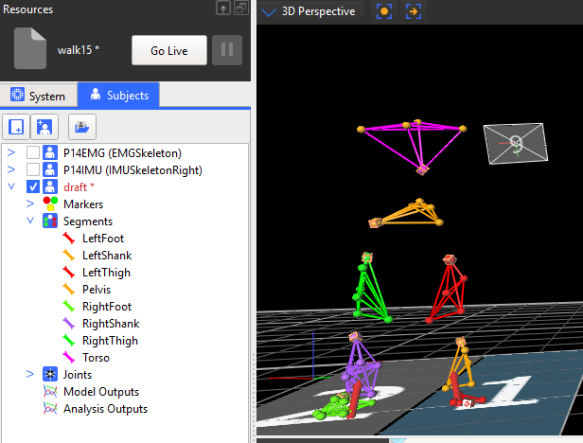

Figure 6 Segments

To begin linking we must go back to our subject preparation tab on the right hand side and head down to link segments. Choosing the appropriate linkage between bodies and press link. We are then required to choose a parent segment, again this will be the proximal segment.

Using the drop down menu, go through selecting linkages between segments, until they are all appropriately joined.

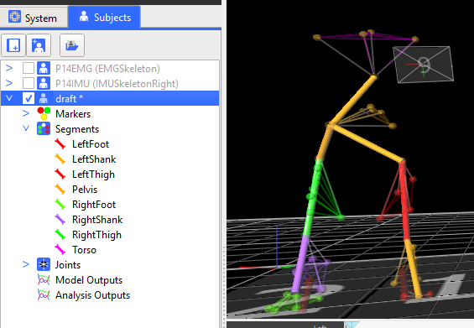

Figure 7 Linkages

We can then press link again on the right hand side, if all segments are linked we will see our subject name is now black. We have correctly linked the joints and created our skeleton. We now save our skeleton by right clicking “draft” and selecting save label template and then save subject, our asterix will then disappear and this skeleton is ready to use again.

## 2.2 Applying a VST

From the previous section2.1 we now have our own VST created that we can apply to another skeleton. There are multiple ways of applying our VST, I applied two of these; manual labelling and auto initialising to best regenerate my labels.

### Subjects

Begin in the next trial by creating a new subject from our template. Clicking the blue person button in the subjects tab on the left hand side. We then browse for our previously saved template and select it.



Figure 8 Applying a VST

A new subject will be created, named as specified with the template in brackets following this.

Though we have a template, we do not have any labels attached to our markers. We now have a few choices and options to label our marker, utilising manual methods or generating from relative position in our saved VST.

### Trajectories

To understand labelling, we must first understand trajectories in nexus. The position of a marker over a timeframe produces a ‘trajectory’, this trajectory can be viewed by selecting the marker, or markers by clicking on them or holding alt and selecting the area.

It is important to note that **after labelling, these trajectories are fixed**, and to alter, you must reconstruct the data, or alter trajectories individually. This will be discussed further in gap filling.

**Trajectories are made differently in manual labelling and in automatic labelling**. In automatic labelling the current position of the labels are constantly referenced against the VST, positioning against this reference. Manual labelling however does not have a reference and produces trajectories from previous points. **This results in more unlabelled trajectories from manual labelling and more mislabelling in automatic labelling.**

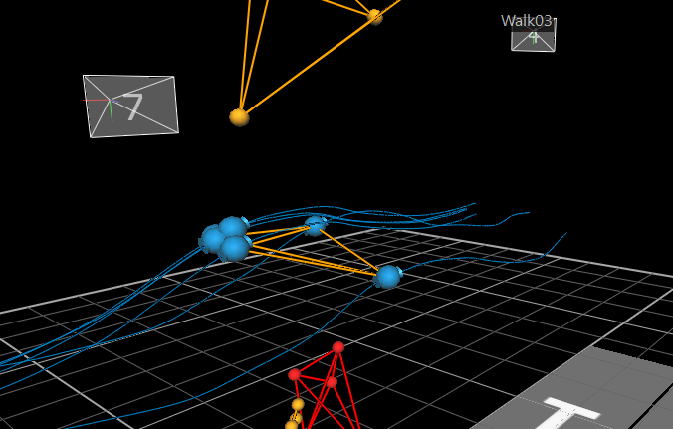

Figure 9 Marker trajectories for pelvis section

### Auto Initialising Labels

Auto initialising labelling can be a lot faster process for labelling. This process uses relative positions of each marker from your VST and labels them, constantly tracking and labelling markers throughout the trial. This process is **definitely best used for static trials, and skeletons with large distance between markers**. You will save a lot of time using this method, but must watch for mislabelling and marker swapping. Both of which we will touch on later.

To best Label Automatically we must become familiar with the pipeline region of Nexus. This is located in the right hand tools section represented with a gear icon.

#### Pipeline Parameters

The pipeline contains various processes that you can carry out on the trial to analyse it. We may now either use the drop down menu to choose a labelling pipeline, or use the label function under core processing in the available options section. In figure 7 I have chosen the reconstruct and label pipeline, and the label option to showcase both.

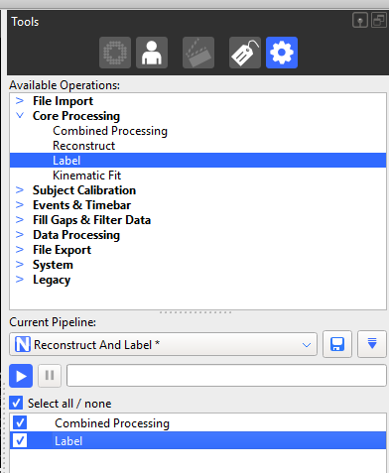

Figure 10 Pipeline

To run the pipeline, simply select the desired operation and press run.

If we were to run the pipeline on a static subject we will find the markers all seem to be labelled correctly. We can then hover the mouse over the labels to check, or press control and spacebar to toggle labels on.

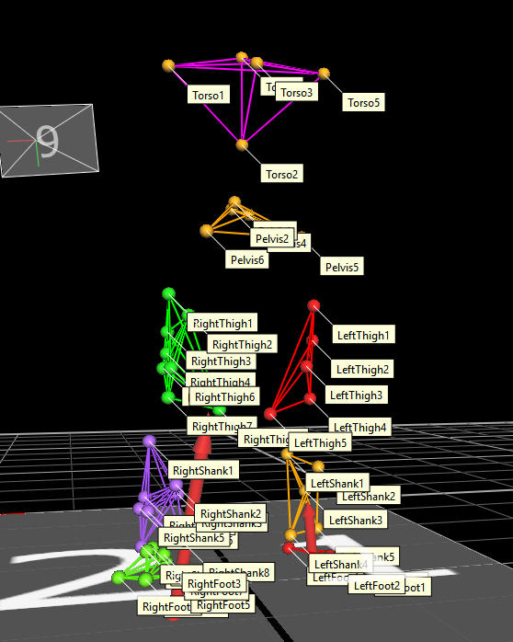

Figure 11 Checking for mislabels

In many cases, we may find that **pipeline parameter need to be changed to optimise this function.** This can be done by showing the advanced section below the pipeline and changing parameters. It is **generally a good idea to increase the smoothing function, booting quality and tracking quality.**

#### Correcting Mislabels

We may then have to change labels if they have been incorrectly labelled, this can be done on the label/edit tab in tools. This table lists all our current markers, and to label them we can click on the mislabelled marker in the table, then match this with our marker in the 3d perspective window.

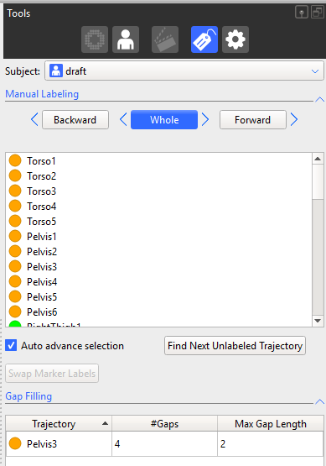

Figure 12 Label/edit tab

To check the whole trial is labelled correctly we then proceed through the rest of the frames checking for unlabelled markers and incorrect labels.

Any easy way to check first for unlabelled markers is to press the “find next unlabelled trajectory button” with “auto advance section” ticked on, this will go through frames and identify unlabelled markers. We can then label from the table as aforementioned or right click on the marker to give available unlabelled options.

From this point we should have a trial with no unlabelled trajectories and we may now proceed to section 2.3 gap filling.

### Manual Labelling

As previously discussed in Trajectories, Manual labelling is created from the tracking of previously labelled markers throughout the trial. This results in a high accuracy of markers, but a lot of clicking. **Manual labelling is best suited when automatic labelling results in a lot of swapped markers and mislabelling despite changing the pipeline parameters.**

To manual label, it is best to have the subject in a position where all markers are visible and identifiable. We can then use our label/edit tool, having selected our “auto advance selection” and click on our very top label of our skeleton.

We are then given a cross as our cursor to select the appropriate marker. Once the appropriate marker is selected we will auto advance to the next one, until our skeleton is fully labelled and is highlighted again.

To solve the unlabelling problem we can use our labelling methods and the “find next unmarked trajectory” to toggle through. As shown in *Correcting Mislabels.*

As with automatic labelling we should proceed onto gap filling when we have a trial with no unlabelled trajectories.

### Timeframe considerations

In Many instances we do not wish to analyse our whole trial at once. This may be due to the subject walking out of frame, or no markers in certain sections. To analyse certain sections we may use the frame markers to trim the trial down. Nexus will update to only show data missed labels and gaps from this section.

This is shown on *figure 11* the subject was previously out of frame and I wish to analyse from 1100 to 1750 frames. I have moved the frame range (triangle sliders) by right clicking and “selecting set region of interest” to do this. From this point I was able to reconstruct and label this section of the trial only.

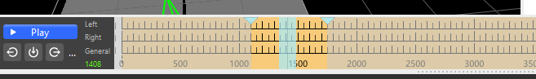

Figure 13 Timeframe Considerations

**Be very careful with this, as saving will automatically trim your data down.** It is best to record the frames that were analysed, so they are ready to support, revert back to the whole frame size and then save.

## 2.3 Gap Filling

As mentioned in Applying a VST creates gaps. And certain methods can be taken to reduce these, but you must almost certainly have some gaps in your data.

### Quality

The quality tab is important in seeing the gaps and labels missing in your data set. This can be found on the bottom tab. The circles with each label represent the percentage labelled by the overall circle colour ranging from red to green. And the smaller circle represents the gaps within the particular marker.

We are aiming for no gaps and 100% of markers labelled accurately. It is important to note that although **quality will indicate whether markers are all labelled it will not tell you if they are labelled incorrectly.**

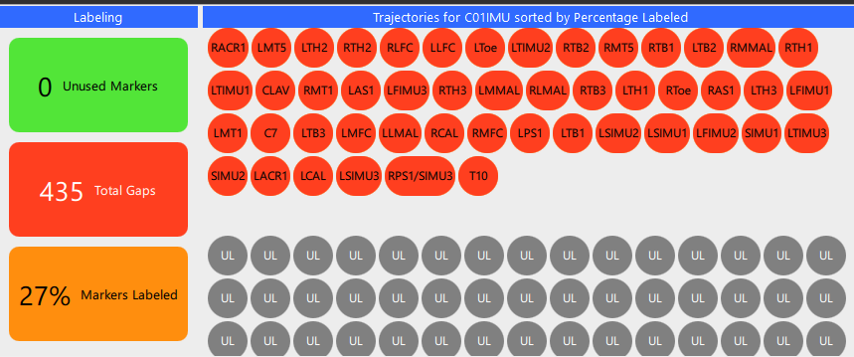

Figure 14 Starting Quality Tab

For the instance in *Figure 12* we have hardly labelled and see that the quality tab reflects this, showing a huge amount of gaps and only 27% of markers labelled.

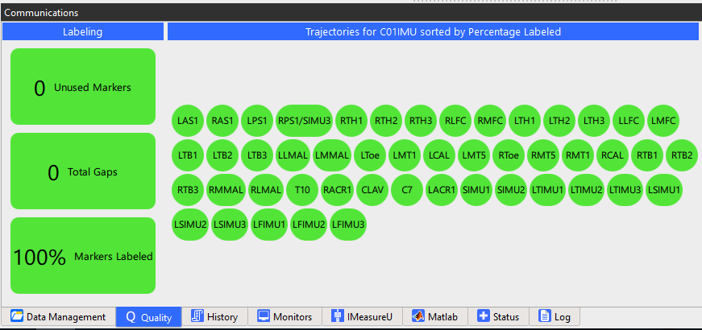

Figure 15 Finished Quality Tab

Whereas in this trial, we have completed gap filling and marker labelling and this is shown again in our quality tab. **This is how all of your finished trials should look.**

### Path Switching

Path switching can occur for many reasons. This can be due to markers being very close together, overlapping, and becoming covered, or poor label parameters.

One of the bigger difficulties is that path swapping can be hard to recognise, as we often group rigid bodies by the same colour. So we will not notice switching. It is always best to check the trajectories throughout the trial to avoid path switching as this will create inaccurate data.

A path switch is identified by a jagged change in direction with another marker, this is shown in *figure 14.*

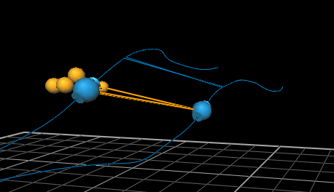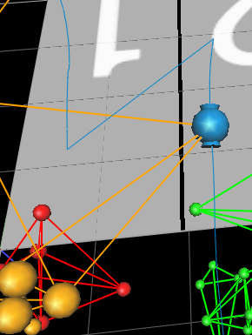

Figure 16 Path Switching

We can see that the two trajectories have swapped paths at the position shown.

To solve this problem we select both markers and **go to the frame where they have just swapped** (this is the very first frame where the markers are labelled incorrectly).We then press the forward direction and then swap marker labels, as shown on *figure 15***. It is important to understand the direction** **convention,** this will change the relative labelling of the trial, in this instance labelling forward of this point, as we wish to keep the previous correct labelling.

If we were to use the whole direction, this would keep the current trajectories and path swap, just label them differently throughout the whole trial.

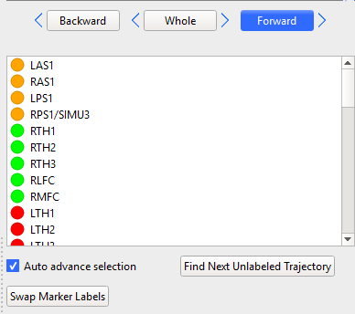

Figure 17 Path switching direction

This process must be done for all path swaps points, in some instances we will see many path swaps.

### Path Filling

Once we have ensured all trajectories are correct, and labelled we must begin to fill the gaps in our data. We use a variety of patterns and assumptions for this, so it is useful to understand these to better apply them. It is easy to fill all gaps, harder to fill them correctly.

To fill gaps we must again refer to our label/edit tools. At the bottom of this tab we will see options for the different fill types. First we must select the gap we wise to fill from the gap filling list, shown below on *figure 16,* then proceed to an appropriate fill type below.

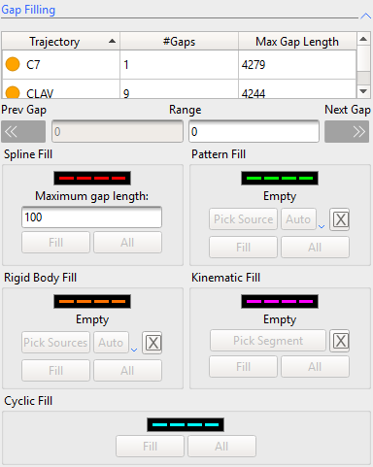

Figure 18 Gap filling tab

For all fills, **we must ensure that the fit is appropriate**. Also taking care to select reference markers that have appropriate trajectories, some can shake on clothing, or wobble on skin and are **not fit for referencing.** The length of fit is also an important variable, for very small gaps or a couple of frames there will be little deviance and so most fits will be acceptable. However we must be careful with vary large fits, especially those which do not follow a predictable pattern.

All fills are shown as a dotted line before confirming along with reference trajectories.

#### Rigid Body

When using the rigid body fill, we approximate all chosen markers as a rigid body, and Nexus uses the relative position of these, and their trajectory to estimate a path.

This is a good estimation when all particles follow a reasonable smooth trajectory, and are on a region such as the pelvis, we can assume as a rigid body.

For this fit 3 markers are required.

#### Pattern Fill

A pattern fill uses one reference marker to estimate the trajectory of a marker. This is usually a good fit when there a less than 3 markers available on a rigid body and there is a suitable marker close by that follows the same trajectory on a rigid body.

## 2.4 Exporting Data

Exporting Data is relatively easy in Nexus. In the pipeline, select the export tool and pipeline, expand the advanced section, and select the relevant devices. However in a lot of cases post processing is required to get the data in the required format.

### ASCII RAW DATA

Exporting asci is very helpful, this allows us to pinpoint exact devices to export individually. However post processing is required for Opensim reading.

Use this for IMU and EMG exporting on its own.

### MOT DATA Opensim

Exporting the MOT data from Opensim requires ground reaction forces to be present. All headers are correctly exported through this, but typically is only useful for exporting the ground reaction forces, nothing else.

### TRC DATA Opensim

TRC Data contains all the marker positions and there movement over time. This should require no post processing and is compatible with Opensim.

# 3.0 Data Filtering

## 3.1 EMG Data

EMG Data filtering was done using Matlab scripts created by Duncan. These scripts use the file output from nexus to return filtered data.

This data is filtered using a Butterworth filter initially, rectifying then applying a low pass filter. This is based of Ajay Seck’s code written for use with open sim, this can be found in references.

To ensure we have appropriate data recorded, and filtered, we should understand how each process is undertaken and what is expected by each stage

### EMG data in Nexus

EMG data in nexus is extremely messy and will not follow distinct patterns. This is because there is a lot of noise. We should however see an increase in the values while the subject is more active.

Data should be exported as ascii format, as per section 2.4. Exporting only the appropriate emg variables.

### EMG Data in Matlab

The matlab code is located in PostProcessingCode in the google drive. This Explains how the code works and shows the before and after effects of the processing. We should see similar patterns just less disruption. Use previously worked data to examine further.

## 3.2 IMU Data

All IMU analyses was done by Ted Yeung. He used the IMU outputs along with initial coordinates and scaled Opensim models to recreate IMU driven Opensim models. No filtering is required of the IMU data, however it is important that the data is in a readable for mat for Opensim.

The required file format is a MOT file, with only IMU data. So some header manipulation maybe required. See scripts for code.

# 4.0 Opensim

Opensim analyses requires a specific Opensim model, tracker markers (.trc file) and various setting specifics (.xml file). To become familiar with the Opensim workspace it is recommended to complete the 3 tutorials located in help tab in Opensim.

A detailed work through for all processes is located on the opensim website [4]

## 4.1 Original Model

The original model is very important for scaling and labelling purposes. This original model should be a representation of your actual model, labelling all markers correctly and in the same place as the model.

Usually a default Opensim model such as Gait2392 is a good point to start.

Markers can be moved around by selecting the marker and dragging it in position. You should rotate the view after moving it to get the best results.

Marker labelling is done through the navigator window on the left hand side of Opensim. If this is not showing up, press on the window tab and select navigator. You can then expand the model into markers, by selecting a marker you can change its name, to match the nexus marker. You can also add new markers in this space, and attach them to a body, similar to nexus.

The model will show errors, if a marker cannot be found or is labelled incorrectly.

If a marker is in the wrong place, it is harder to figure out. The model will scale incorrectly, so it is important to always adjust your original marker set to have more accurate scaling.

## 4.2 Static scaling

Static scaling in Opensim is a way of linearly scaling bone sizes according to relative distance.

From our original model above we must create a marker set. The marker set will use distances between markers to scale certain bones. For instance we may use the distance between the hip and knee markers to scale the femur.

## 4.3 Inverse Kinematics

Inverse kinetics is the process of using known positions of points to in the case of Opensim, acquire joint angles. This process uses the know marker points and assuming rigid bodies for each bone.

We use the static model from the previous step, and this time select the Inverse Kinetics tool. The important thing from this step is the weighting of the marker points.

We use the appropriate walking trc file and time range, then begin with an estimate weighting. We will see in the command window how effective our weighting was. We are aiming to reduce the RMS total error and the maximum marker error, making our model as close as possible to the TRC file. This can be done by increasing the weighting for this marker or reduce the weighting on other markers.

The output of our Inverse kinematics is a mot file containing the joint angles through the time period.

## 4.4 Inverse dynamics

Inverse dynamics uses external forces and known kinematics to analyse the moments and force through the different points. In the case of the gait analyses we are using the external force of the treadmill Ground Reaction Forces and our Kinetics from previous.

# 5.0 References

[1] Vicon Motion Systems Ltd 12/2018 *Vicon* {https://www.youtube.com/channel/UCMJ8Y90iMhuBUlTb09LhAFw}

[2] Ajay Seck Aug2008 *Preprocessing Utilities* {<http://simtk-confluence.stanford.edu:8080/display/OpenSim/Tools+for+Preparing+Motion+Data>}

[3] Opensim Feb2016 *Patient-specific Model-building and Scaling with MAP and Statistical Shape Modeling {*<http://opensim.stanford.edu/support/event_details.php?id=149>​}

[4] National Center for Medical Rehabilitation Research (NCSRR) 2017 *Opensim Documentation {*https://simtk-confluence.stanford.edu/display/OpenSim/Getting+Started}